**Unit 4 - Unit Test**

For questions 1-4, **draw and label** a system schema AND a qualitative force diagram that represents the situation. Use marks on the vectors to indicate which forces are equal.

1. Show the forces on the box while raised at constant speed.

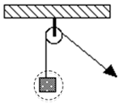



1. Show the forces on the box while moving to the left at constant speed.

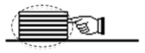



1. Show the forces on block A as it is pulled across a frictionless table.

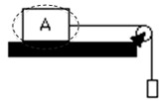

1. Show the forces on the motionless box.



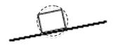

For questions 5-10, it is possible to have **MORE THAN ONE correct answer.** Sketching a force diagram may help!Write each correct answer in the **blank**.

1. _________ One of your classmates takes a broom and gives a bowling ball a *brief push*. A moment **after** the push, which of the following forces are NOT acting on the bowling ball?

|  |  |  |  |
| --- | --- | --- | --- |
| 1. The force of the push | 1. A normal force | 1. Inertia | 1. The force of gravity |

1. _________ Which of the following describes the motion of the air hockey puck after a push, in the simulation? *Reminder: Simulation 1 was frictionless.*

|  |  |  |  |
| --- | --- | --- | --- |
| 1. The puck moves at a constant speed | 1. The puck slows down gradually to a stop. | 1. The puck continues at constant speed for a while, then slows down. | 1. The puck accelerates constantly. |

For questions 7 - 10 refer to the diagram below. A student attaches a string to a wheeled cart and pulls with **constant force** on the string. There is **no friction** between the cart and the table.

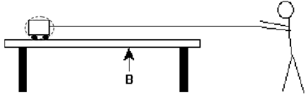

1. __________ Select all of the following forces that act on the cart as shown above.

|  |  |  |  |
| --- | --- | --- | --- |
| 1. Tension force | 1. Normal force | 1. Inertia | 1. The force of gravity |

1. __________ Which of the following describes the motion of the cart while it is pulled with a **constant force** across the table? The cart...

|  |  |  |  |
| --- | --- | --- | --- |
| 1. moves at constant speed | 1. slows down gradually to a stop | 1. speeds up for a bit, then moves at a constant speed | 1. accelerates constantly |

1. __________ When the block reaches point B, the string breaks. Which of the following now describes the motion of the cart as it moves across the table? The cart...

|  |  |  |  |
| --- | --- | --- | --- |
| 1. moves at constant speed | 1. begins to slow immediately | 1. continues at a constant speed for a while, then slows down | 1. continues to accelerate constantly |

1. __________ Eventually, the cart travels off the edge of the table. After the cart leaves the table and is in the air, identify each of the following forces that act on the cart?

|  |  |  |  |
| --- | --- | --- | --- |
| 1. The force of motion | 1. A normal | 1. Sliding friction | 1. The force of gravity |

For questions 11-12, either show your work or explain your reasoning.

1. A man pulls a 50 kg box at a constant velocity. He applies 200 N of force parallel to the ground.

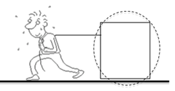

* 1. Draw a system schema for this scenario.
  2. Draw the force diagram for the box.
  3. What is the value of the frictional force opposing the motion?
  4. What is the value of the gravitational force?

1. The classic toy *Barrel of Monkeys* is arranged in a chain as shown to the right. Each monkey has a mass of 15 grams.



1. Draw a system schema and force diagram for monkey 3.

b. What is the sum of the forces pulling down *on* monkey 3?

c. What is the magnitude of the force exerted by monkey 2 on monkey 3?

13. George has a mass of 100 kg on Earth.

a. What is the force of gravity on George? Show your work.

b. What is George's mass on the moon where the force of gravity is approximately 1/6 of Earth's? Explain or show your work.

4. Martha has a force of gravity of 360 N on Earth.

a. What is Martha’s mass on Earth? Show your work.

b. What is Martha's mass on the moon where the force of gravity is approximately 1/6 of Earth's? Explain or show your work.